Github Assignment

1. Create a directory ‘project_dir’ and cd to ‘project_dir’

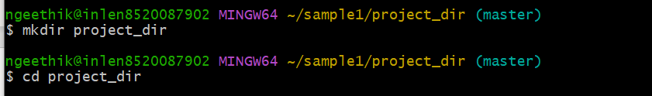

2. Intialize git version database(git init)



1. Create a new file index.html



1. Check the git status.you should find index.html as untracked file.

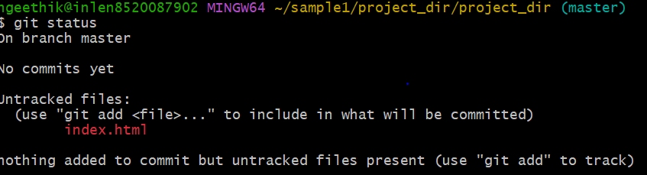

1. Stage the index html.file



1. Commit index.html

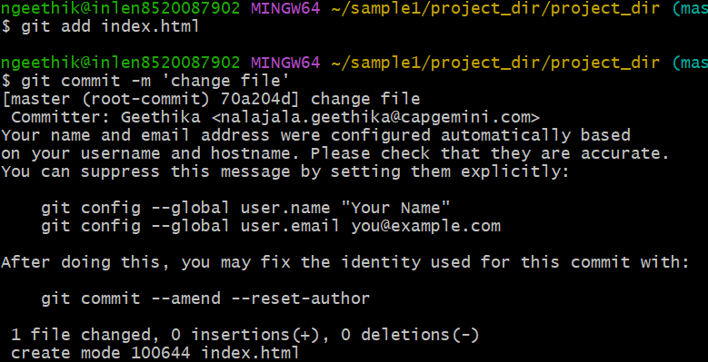

1. MAKE A change in index.html & create a new file info.txt fi

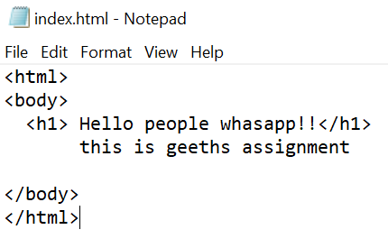

create a new file info.txt file



1. Check the git status. You should find index.html as untracked file

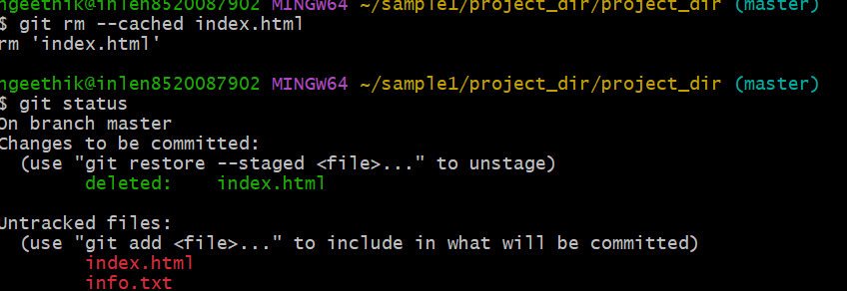

1. Configure git to ignore all txt files

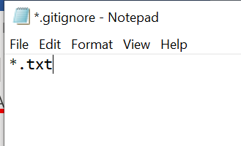

1. Again check the git status. you should find only index.html as untracked file

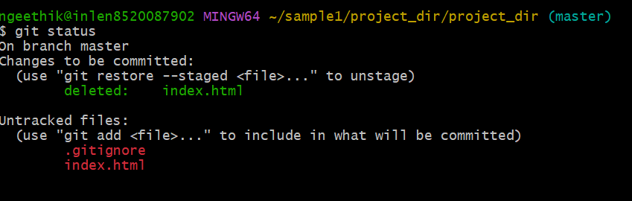

1. State & commit index.html

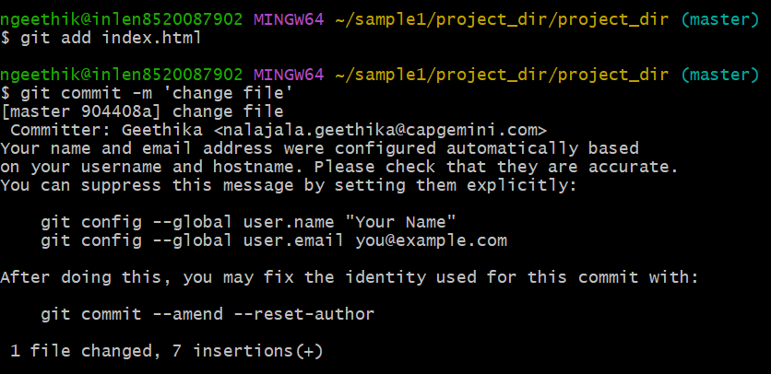

12.Log all your comments so far

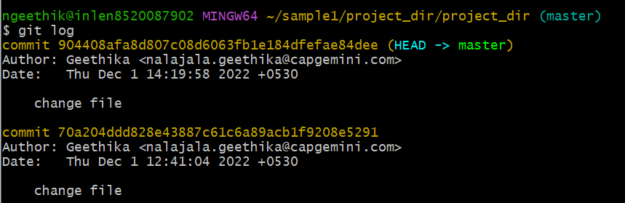

13.Make some changes in index.html

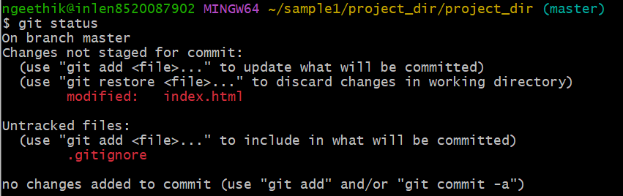

14.Revert the changes made in the previous step using git command

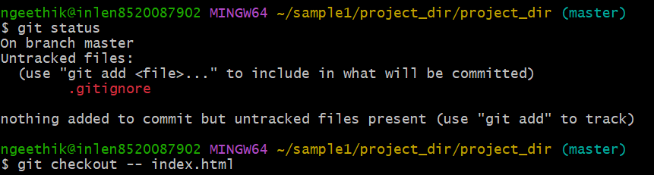

15.Again change index.html

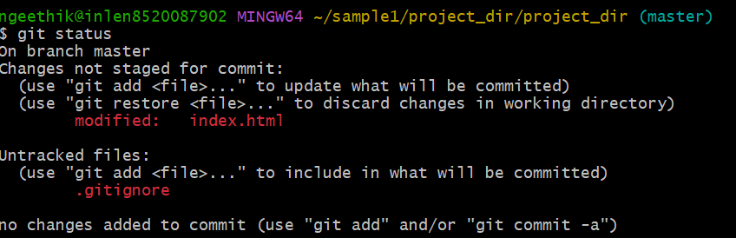

16. Stage index.html



17.Revert back the last stage.



18.Rename ‘add’ command to ‘my-add’

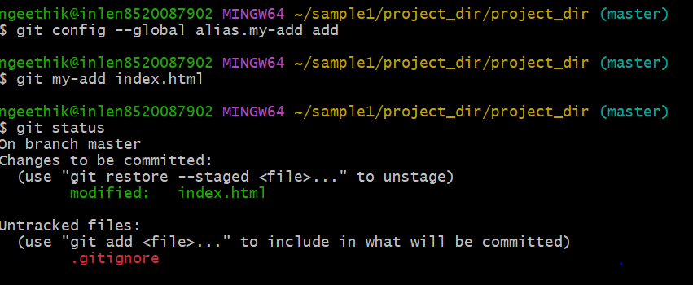

19. Using my_add command stage index.html.html again & commit the changes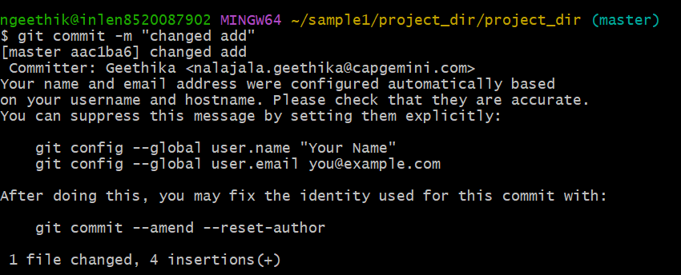

20. Revert the last commit.

